Connor Morrison

RASPBERRY PI WEB SERVER ARCHITECTURE

Contents

Server Architecture 2

Key Requirements 2

Non-functional Requirements 2

Hosted Projects ASRs 2

Hardware 2

Dependencies 2

Server and Delivery 2

Front-end 3

Back-end 3

External Dependencies 4

Architecture 4

Diagrams 4

Questions 4

Projects 5

Portfolio 5

Abstract 5

Key Requirements 5

Content 5

Prompt Engineering 7

Game Style Form 7

Abstract 7

Key Requirements 7

Virtual Chatbot 8

Abstract 8

Key Requirements 8

Biometric 2FA 8

Abstract 8

Key Requirements 8

# Server Architecture

## Key Requirements

#### Non-functional Requirements

* Availability
* Reliability
* Lightweight

### Hosted Projects ASRs

#### Portfolio Display

* Must be responsive suiting both mobile and web displays
* Must be dynamic, loading elements as the user scrolls
* Must be modular, new elements must be able to be created and recreated with ease.

#### Game-style Form

* Must submit data to a persistence database

#### Virtual Chatbot

* Must be lightweight as to not deplete the server’s resources

#### Biometric 2FA

* To be decided

## Hardware

#### Raspberry Pi 4

* CPU – Quad core Cortex-A72 (ARM v8) 64-bit SoC @ 1.8GHz
* RAM – 8GB LPDDR4-3200 SDRAM

## Dependencies

### Server and Delivery

#### Dynamic Domain Name Service – No-IP $→$ NameCheap

I plan to begin with No-IP’s free DDNS service for initial development with later planned integration to NameCheap’s DDNS service with custom IPs as this will improve accessibility and the user experience of the website giving a more professional experience to viewers.

#### Web Server Software – NGINX

NGINX was chosen for two main reasons, it’s highly lightweight architecture and for its popularity. The lightweight architecture was preferred due to the limited resources on the Raspberry Pi. The other reason was popularity, as I was inexperienced in working with NGINX it was crucial to have sufficient documentation and tutorials to learn as the project grew. One other main option was considered, Apache, this was rejected due to its heavyweight size that would be too demanding on the resources of a Raspberry Pi 4.

#### Containerisation – Docker & Docker Compose

Docker was chosen to containerise each microservice, the issue with this was from the container overhead, which may stress the CPU. However, it was decided to focus on using lightweight frameworks in each stage and implement restrictions on how much memory and CPU each container has access to. With Docker compose to manage the many containers used for the microservice architecture it is a sufficient choice.

### Front-end

#### Front-end Library – React

React was chosen as a front-end library due to the importance of modularity to future development, allowing for the creation of repeatably used assets. Also, React is a popular library with significant user support, this means solutions will be easier to research and work towards.

#### CSS Library – TailwindCSS + daisyUI

TailwindCSS was chosen as the most suitable CSS Library, this was for two main reasons. Tailwind offers more customisation over elements whilst still allowing to serve the practicality of a CSS Library, allowing for a more personal user experience. The other was that Tailwind can be combined with daisyUI to deliver predefined elements with ease. The main competitor considered was Bootstrap, however this was not chosen as apps developed with Bootstrap always look like a “Bootstrap app”, I personally wanted more customisability in my design choices than that, hence Tailwind.

### Back-end

#### Back-end Framework – Flask

Flask was chosen as a backend framework for its lightweight design and my Python language skills. Although Flask may take more work implementing what I need for each service as I develop this will be rewarded with a much more lightweight app which can be hosted on the Raspberry Pi.

#### Database – SQLite

This database was chosen due to its lightweight architecture however if the app were needed to scale it may be worth considering using a Redis database where appropriate to allow for frequently accessed data to be cached for quick access, although it may be more beneficial to add more Raspberry Pis to scale horizontally in this intense usage.

### External Dependencies

#### Chatbot - Azure AI Bot Service

The Azure AI Chatbot offers a free service for up to 10,000 messages (HTTP requests) per month and is always free. Another reason why this was chosen over hosting an open source Chatbot like Radas or Botpress is due to the resource demand these AI models would put on the Raspberry Pi.

## Architecture

### Diagrams

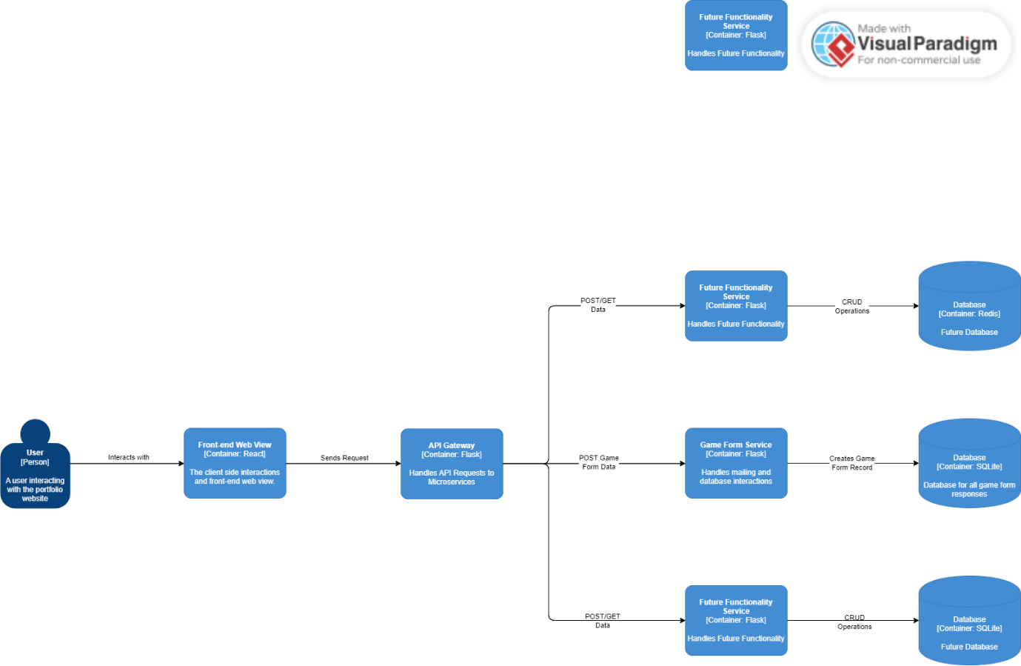

## Questions

* How to best address certain security concerns? Reference OWASP and Vulnerability Testing Tools???
  + Form input (XSS and SQL Injection)
  + Firewalls

# Projects

## Portfolio

### Abstract

### Key Requirements

#### Functional Requirements

* Must be modular, allowing for new sections to be added and dropped with ease.
* Must display all information in the Content section below
* Must be responsive suiting both mobile and web displays
* Must be dynamic, loading elements as the user scrolls

#### Non-functional Requirements

* Must have a sleek user interface

### Content

#### Experience and Projects

* Software Developer at Department of Employment and Workplace Relations (Feb 2024 – Present)
* Raspberry Pi Web Portfolio (Jun 2024 – Present)
* Freelance Web Developer (Jan 2023 – Feb 2024)
* MenuScan (Mar 2024 – May 2024)
* 2032 Brisbane Olympics Extended Reality Experience (Jul 2023 – Oct 2023)
* Gardens of the Galaxy (Jul 2023 – Oct 2023)

#### Programming Languages

* Python (Strength 5/5)
* Java (Strength 5/5)
* HTML (Strength 5/5)
* CSS (Strength 4/5)
* C# (Strength 3/5)
* JavaScript (Strength 4/5)
* SQL (Strength 4/5)
* PHP (Strength 3/5)
* MatLab (Strength 2/5)
* RStudio (Strength 2/5)

#### Technical Software Skills

* Linux
* Terraform
* Docker
* Amazon Web Services
* NGINX
* Microsoft SQL Server
* Git
* Figma

#### Frameworks & Libraries

* Node.js
* Flask
* .NET
* Vue.js
* React
* React Native
* Bootstrap
* TailwindCSS

#### General Development Skills

* Cloud Computing
* Full-Stack Web Development
* RESTful API Development
* Containerisation
* Object Oriented Programming
* Testing
* Problem Solving
* Cyber Security

#### Education and Certification

* Bachelor’s degree in computer science from UQ (2021 – 2024)
* Certificate II in Information, Digital Media, and Technology (2019 – 2020)
* Google Cybersecurity Professional Certificate
* Mozilla JavaScript Professional Certificate
* OpenEDG Python Professional Certificate
* Docker Professional Certificate
* *Career Essentials in GitHub*

#### Other

* Security Clearance – Negative Vetting 1

### Prompt Engineering

Take on the role of a web programmer and designer to design me a single page web application built to my specification.

To design the website please build it using React, feel free to create any components necessary to design the page. For a CSS framework please use TailwindCSS for styling. For the colour palette please use these colours: #000000, #14213d, #fca311, #e5e5e5, #ffffff (feel free to use the closest Tailwind alternatives if not available). The page must be responsive and suitable for mobile and web viewing. HTML should be semantic where possible. The page should have animations trigger as the user scrolls presenting them with new information.

To give you context of the website, I am a web developer who is looking to build a portfolio website showcasing my experience, qualifications, skills… (all of which will be listed below). For any skills that have strength value please show a stylised representation of this e.g. filled circles out of 5. Also, please include icons/logos as well wherever possible to represent softwares. Feel free to use as long of a response as required to satisfy the prompt. The content you require to be displayed is:

*Content section*

## Game Style Form

### Abstract

Think of a falling block/ball (addressed as the Selector) game that has buckets the player can direct the Selector into that have replies to form questions that can be sent back to the database. Once questions have been answered, users can input their name in a game like keyboard to add their “high score” to the board (every player gets the high score) (this “adding their score” submits to the data to the database).

### Key Requirements

#### Functional Requirements

* Must submit data to a persistence database
* Upon submission an email should be sent to me with the users replies

#### Non-functional Requirements

* Must have a fun colourful UI (think like Tetris I reckon)
* Must have an easy to use and practical control scheme
* Must seamlessly fit in with the user interface
* Mustn’t cause lag for the page

## Virtual Chatbot

### Abstract

A virtual chatbot to answer questions relating to my experience in computer science and my qualifications + experience.

### Key Requirements

#### Functional Requirements

* Must reply within 5 seconds of asking a question

#### Non-functional Requirements

## Biometric 2FA

### Abstract

### Key Requirements

#### Functional Requirements

#### Non-functional Requirements